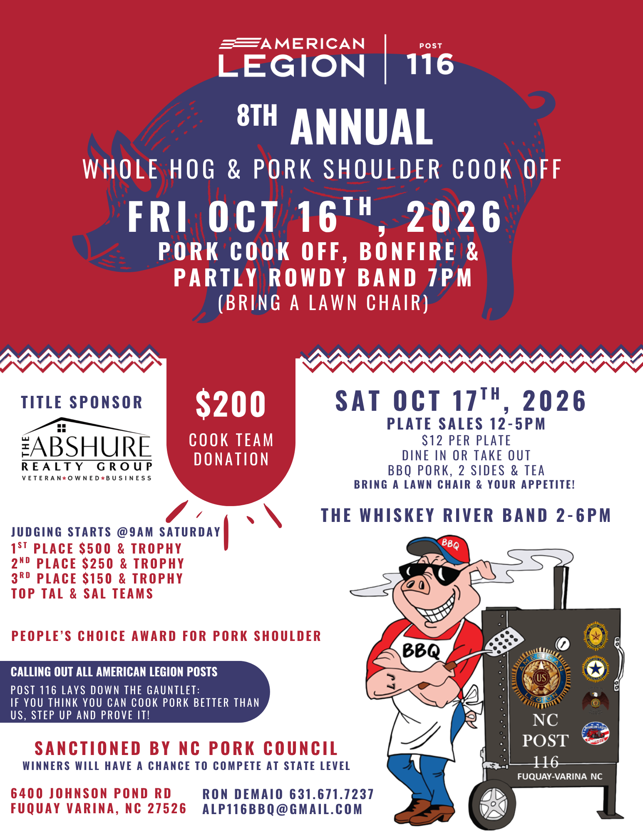

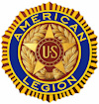 AMERICAN LEGION 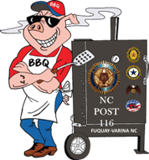 POST 116, 6400 JOHNSON POND RD. FUQUAY-VARINA, NC 27526
WHOLE HOG & PORK SHOULDER COOK OFF (OCT 16th & 17th 2026)
BBQ Cook-Off Prize List, Rules & Regulations
Welcome to The American Legion Post 116 Cook- Off! Below you will find the prize list, rules, and regulations for our cook-off. This is a North Carolina Pork Council (NCPC) Sanctioned Event. If you have questions please contact: Ron Dermaio at 631 671-7237 ALP116BBQ@gmail.com
Division & Prize List:
Culinary Division
1st Place Trophy & $500 Cash, & may enter
NC Whole Hog Barbeque State Championship (*with 10 or more entrees)
2nd Place Trophy & $250 Cash, & may enter
NC Whole Hog Barbeque State Championship (*with 11 or more entrees)
3rd Place Trophy & $150 Cash, & may enter
NC Whole Hog Barbeque State Championship (*with 11 or more entrees)
Blind Taste Division
1st Place Trophy & $100 Cash
American Legion Top Team
1st Place Trophy & $100 Cash (*with 2 or more entrees)
American Legion SAL Top Team
1st Place Trophy & $100 Cash (*with 2 or more entrees)
People’s Choice Award
1st Place Trophy & $100 Cash
Blind BBQ Sauce Award
1st Place Trophy & $50 Cash
Trophies and cash prizes will be awarded the day of the contest.

BBQ Cook-Off Rules & Regulations
- Each team must have a Chief Cook and no more than 3 assistants.
The Chief Cook must be at least 18 years old.
- Whole hogs will be provided and may be prepared on a wood, charcoal, or gas fire. Meat for the contest entry may not be precooked or cured in any way prior to inspection at the beginning of the contest. Cooked meat must be hand chopped after Judging.
- The competition site will be at American Legion Post 116, 6400 Johnson Pond Rd Fuquay-Varina, NC 27526.
- Cook sites are first come first serve. Teams may begin arriving no earlier than 3 PM on Friday October 16th and should be checked in by 7 PM. An event Official will show you to your available cook site.
- Teams will be permitted to begin setting up their equipment any time after arrival.
- A mandatory Chief Cooks meeting will be held on Friday night October 16th at 7:00 PM in building number 1. A drawing will determine the on-site judging order.
- The American Legion Post 116 will provide and approximate 10’x 20’ cooking area, A 100 -125 lbs. pig, 15 lbs. Sholder/Butt (to be used for Peoples Choice & Blind taste Competition), A trash bag for pig remains, and containers for cooked / hand chopped BBQ. The team shall provide all other equipment and supplies to include cooking ingredients, grills, utensils (Including stem thermometers), Drip pans, Tables, Tents, Chairs, Fuel (Wood, gas, or charcoal), Burn barrels, a fire extinguisher, chopping equipment, something to cleanse the pallet of the in NCPC on site judges and any items or materials which the cook desires. Chief Cooks should take special note of the “Completeness” criteria on the onsite score sheet. Teams must have containers to carry and hold water. Pigs will be distributed to sites by event personnel at approximately 7:30 PM on 16 October 2026 and the cook off will officially begin at that time. Teams are not allowed to choose pigs.
- Each team must comply with all applicable rules and regulations of the County Health Department, including but not limited to:
  - After cooking, meat must be maintained above 140 degrees Fahrenheit and covered.
  - Aprons and hats must be worn by all cooks and assistants.
  - Cleanliness of cooking area and personnel is required.
  - Hands must be frequently and thoroughly washed.
  - No pets or small animals are allowed in cooking areas.
- All contestants are requested to respect the rights of all other contestants with special emphasis relating to loud music, loud and or profane language or infringement on an adjoining cook site with any equipment, coolers, etc... The chief cook will be responsible for the conduct of his / her team.
- CONTESTANTS MAY NOT SELL ANY FOOD, DRINK, SOUVENIRS, OR ANY OTHER ITEMS TO THE GENERAL PUBLIC.
- No Off- site alcohol will be allowed to be brought or consumed on property.
- No passes will be given at judging time. If the team’s pig is not done or ready, team will be disqualified.
- All teams will be provided with a sample score sheet, a complete set of rules and regulations and a schedule of events.
- Drip pans must be used to catch grease. A grease barrel is located behind dumpster for disposal.
- Burn barrels will be the responsibility of each team and they must be in an area away from tents to avoid damage to property and off pavement.
- Open fires on the ground will NOT be allowed, for making coal, due to safety concerns. See rule 15 or burn barrel guidelines.
- Grounds for Disqualification:
  - Pigs should not be sauced or injected inside or out. Sauced or injected pigs will be disqualified.
  - NCPC rules do allow salt and soda to be used on meat and external skin during cleaning and preparation stage to draw out moisture and blood. The pig must then be cleaned of salt and soda. Salt, soda, and oil may be used on the external skin during the cooking process.
  - No external heat source may be used other than the cooker /grill. Examples include, but are not limited to, heat guns and torches.
  - Final determination of a pig’s suitability for purposes of consumption will be based on inspection by judges. The judge’s decision will be final.
- All pigs must be cooked in an above ground cooker. If using a gas cooker, it must meet current safety standards such as a proper regulator, have UL approved hoses, and tank must be secured to prevent tipping.
- If a Chief Cook desires to withdraw, he or she must notify the American Legion post 116 BBQ committee immediately.
- Culinary Division On-Site Judging will begin at 8 AM on October 17th, 2026.
  - During On-site judging for the Culinary Division no trophies or pictures of awards can be displayed.
  - See attached On-site Culinary Score Sheet.

- Blind Taste Test Competition Judging will begin at 10 AM on October 17th, 2026.
  - The Pork Shoulder will be used for the Blind Taste Test Competition.
  - The Pork Shoulder can be cooked anyway the Chief Cook desires, as long as it has an internal temperature of at least 160 degrees Fahrenheit.
  - American Legion BBQ Committee will check the Pork Shoulder to ensure it is done. If not at 160 degrees Fahrenheit, the team will be disqualified from the Blind Taste Test Competition and the People’s Choice Award.
  - American Legion cook-offs staff will provide each team with an unmarked container for a portion of their Pork Shoulder BBQ and a secret number, known only to Chief Cook, for identification.
  - See attached Blind Taste Judging Score Sheet.
- People’s Choice Award will be awarded to the team that collects the most votes by the people attending the festival.
  - Attendees of the festival wishing to participate in the People’s Choice Award Competition will be sold 1 ticket per entered team and a coin to give the best cook team, for $10.
  - Participants will then be able to give 1 ticket to each of the entered teams for a sample of their Pork Shoulder BBQ.
  - They will then give their coin to the cook team they determine is the best.
  - People’s Choice Award will not start before teams have turned in their Pork Shoulder samples for the Blind Taste Test Competition.
  - There will be no combining of coins between teams.
  - American Legion cook-off staff will pick up coins at your site promptly at 1pm.
- Blind Sauce Taste Award Judging will begin at 10 AM on October 17th, 2026.
  - No store-bought BBQ sauce will be allowed for the Blind Sauce Taste Competition.
  - American Legion cook-offs staff will provide each team with an unmarked container for a portion of your BBQ Sauce and a secret number, known only to Chief Cook, for identification.
  - Judges will score each sauce from 1-20 highest number wins.
- Top American Legion Post Award
  - Each American Legion Post will be allowed only 1 entry for this award.
  - Will be awarded to the highest finisher in the Culinary Competition.
- Top American Legion Son Post Award
  - Each American Legion Post will be allowed only 1 entry for this award.
  - Will be awarded to the highest finisher in the Culinary Competition.
- Each Chief Cook will have the following on hand for judging:
  - 4 sharp knives
  - 4 cups or bottles of water
  - 4 clothes or paper towels
  - 4 small containers of sauce
  - 2 thermometers are required, 4 recommended
- A representative of the American Legion Post 116 BBQ committee will accompany the judges while pigs are being judged to collect score sheets. The score sheets will contain no information that will identify the cooks or sponsors. Committee staff and judges total score sheet.
- In the event of a tie committee staff will refer to the judging sheets and the winner will be awarded by the highest points in category of Meat Taste if still a tie, then Skin Crispness, then Moisture.
- After on-site judging has been completed, all pigs must be turned in fully chopped, by hand. To obtain a uniform consistency for BBQ plate sale. NO MECHANICAL PROCESSOR OR SLICERS ARE ALLOWED. The AL BBQ committee will provide containers to collect the chopped BBQ. DO NOT APPLY SAUCE TO THE CHOPPED BARBECUE.
- Each team is responsible for cleanup of their area at the end of the contest.
- No pets will be allowed in the cooking area.
- The top 3 winners of the American Legion Post 116 Whole Hog Cook Off will be eligible to enter the NC Whole Hog Barbecue State Championship, if we have 10 or more entries.
- Contest winners will be announced, and Trophies presented at approximately 1:15 PM on Saturday 17th of October.
- AL BBQ committee reserves the right to make additional rules and regulations as the situation warrants. All decisions of the AL BBQ committee and the NCPC judges are final. Violations of any rules or regulations may result in disqualification.
- The American Legion Post 116, its employees, representatives, volunteers, or contractors shall not be responsible or liable for the property of any team, any laws, damage or injury to any team or its representatives. All property of the team shall be under the care, custody, and control of the team, whether in transit to, from, or within The American Legion BBQ Cook Off.

Note: Cooks are encouraged to review on the Whole Hog Barbecue Website, under the section on Sanctioning, the guidelines and rules for competing in North Carolina Pork Council whole hog cookoffs.
https://wholehogbarbecue.com/contest-resources/
AMERICAN LEGION
POST 116, 6400 JOHNSON POND RD. FUQUAY-VARINA, NC 27526
WHOLE HOG & PORK SHOULDER COOK OFF (OCT 16th & 17th 2026)
BBQ Cook-Off Schedule
October 16th, 2026
3:00 PM – 7:00 PM Team arrival and registration
Assignment of cooking spaces
Cook area set up and preparation
7:00 PM - 10:00 PM Partly Rowdy Band
7:00 PM – 7:30 PM Cooks meeting in building 2
7:30 PM – 8:00 PM Teams pick up Pig and Shoulder
Contest begins
October 17th, 2026
8:00 AM – 10:00AM On site Culinary Judging & score tabulation
Collection of hand chopped BBQ
10:00 AM – 10:30 AM Blind Taste Test Judging & score tabulation
10:00 AM – 10:30 PM Blind BBQ Sause Judging & score tabulation
10:00 AM – 1:00 PM People’s Choice Award sampling
12:00 PM – 5:00 PM Sell BBQ Pork Plates until gone
1:15 PM Presentation of Awards to Teams
2:00 PM – 6:00 PM The Whiskey River Band

AMERICAN LEGION POST 116, 6400 JOHNSON POND RD. FUQUAY-VARINA, NC 27526
WHOLE HOG & PORK SHOULDER COOK OFF (OCT 16th & 17th 2026)
Pork Shoulder Blind Taste Competition Guidelines
The blind judging is your finished barbecue product as you want it presented to the judges.
*Entries are a blend of cooked meat, sauce, and seasonings.
*Entries must be turned in within the stated time limit.
*Entries may include individual chips of crackling for the judges, and crackling bits may also be blended into the prepared barbecue, if desired.
*Blind box entries should not include garnishes, extra sauce containers, or foreign objects such as aluminum foil, toothpicks, etc...
*Blind BBQ entries are to be judged on appearance, tenderness, and taste.
*Appearance includes texture, color, fat to lean ratio, burnt meat and the visual appearance of the BBQ as a food product.
*Tenderness is based on moistness and tenderness of the BBQ. Entries should not be dry, burnt, tough or mushy.
*Taste of the entry should be pleasing, should not be excessively hot from the sauce and seasonings, and should also not be bland. The BBQ should be appealing and enjoyable to a typical BBQ customer.
*The NC Pork Council’s Blind Taste Judging Score Sheet will be used for scoring entries.

AMERICAN LEGION 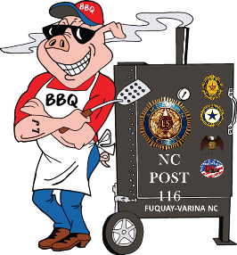 POST 116, 6400 JOHNSON POND RD. FUQUAY-VARINA, NC 27526
WHOLE HOG & PORK SHOULDER COOK OFF (OCT 17th & 18th 2025)
COOK’S ENTRY FORM (FORM MUST BE COMPLETE)
INFORMATION:
TEAM NAME: ___________________________________________________
CHIEF COOK: __________________________________ (NOTE: ALL CORRESPONDENCE WILL BE WITH CHIEF COOK)
ADDRESS: ______________________________________________________
CITY: __________________ STATE: __________ ZIP: _______________
PHONE: _________________ EMAIL: ________________________________
ASSISTANT COOKS (MINIMUM OF 1; MAXIMUM OF 3)
- ________________________________________
- ________________________________________
- ________________________________________
CORPORATE OR AL POST SPONSORS (IF ANY): ____________________________________________________
ADDRESS: _________________________________________________________________________________
FIRST-COME, FIRST-SERVED- ONLY 20 SPACES AVAILABLE!! DEADLINE TO ENTER: 12 OCT 2026
INDICATE FUEL SOURCE: CHARCOAL_______ WOOD______ GAS______
SPACE INFORMATION:
EACH TEAM WILL BE ALLOCATED 1 OUTSIDE SPACE APPROXIMATELY 10’x20’
EACH TEAM MUST PROVIDE THEIR OWN SHELTER. WATER & ELECTRICITY WILL BE AVAILABLE.
ENTRY FEE INCLUDES:
-1 PREPARED 100-125 lbs. HOG (NC PORK COUNCIL JUDGING)
-1 15-18 lbs. PORK SHOULDER (BLIND TASTE DIVISION & PEOPLES CHOOSE COMPETITION)
-1 OUTSIDE SPACE APPROXIMATELY 10’x20’
-2 FREE BBQ PLATES
PAYMENT INFORMATION:
ENTRY FEE FOR COMPETITION IS $200 (WE ARE A 501C VETERANS ORGANIZATION AND WILL PROVIDE TAX LETTER IF REQUESTED)
FEES AND FULLY COMPLETED ENTRY FORM MUST BE RECEIVED BY 12 OCT 2026
CHECKS ARE MADE PAYABLE TO: AMERICAN LEGION POST 116 BBQ
MAIL TO: 6400 JOHNSON POND RD. FUQUAY-VARINA, NC 27526
I have read, and agree to, all rules and regulations of the American Legion Post 116 Cook Off.
___________________________________ ___________________
CHIEF COOKS SIGNATURE DATE
EVENT CONTACT: Ron DeMaio 631 671-7237; ALP116BBQ@GMAIL.COM

